MINISTRY OF EDUCATION AND SCIENCE OF UKRAINE

NATIONAL TECHNICAL UNIVERSITY

“KHARKOV POLYTECHNICAL INSTITUTE”

LABORATORY WORK № 1

# “Basic concepts of programming. Design and Graphical Representation of Algorithms”

Created by student of 1.КН.201.8г

Chukwu Irele Omike

Checked by

KHARKIV 2018

Topic: Creating and graphic submission with using Visual Paradigm for UML.

Goal: Learning Use Case and Activity Diagrams by using Visual Paradigm for UML.

Tasks:

### Individual Assignment

According to the task in Table 1 student should analyze computational algorithms.

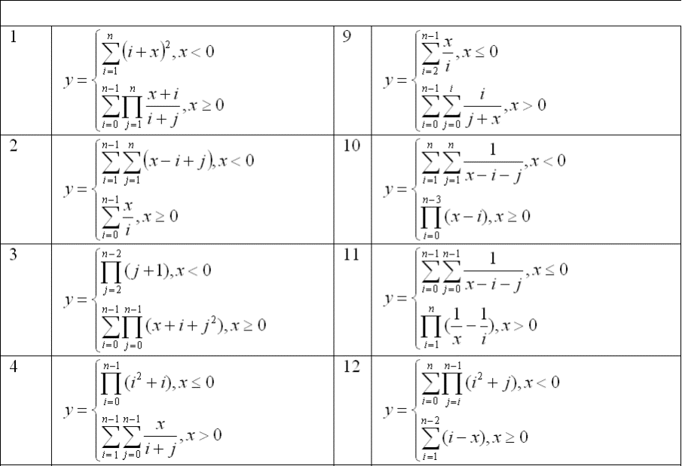

Active diagram

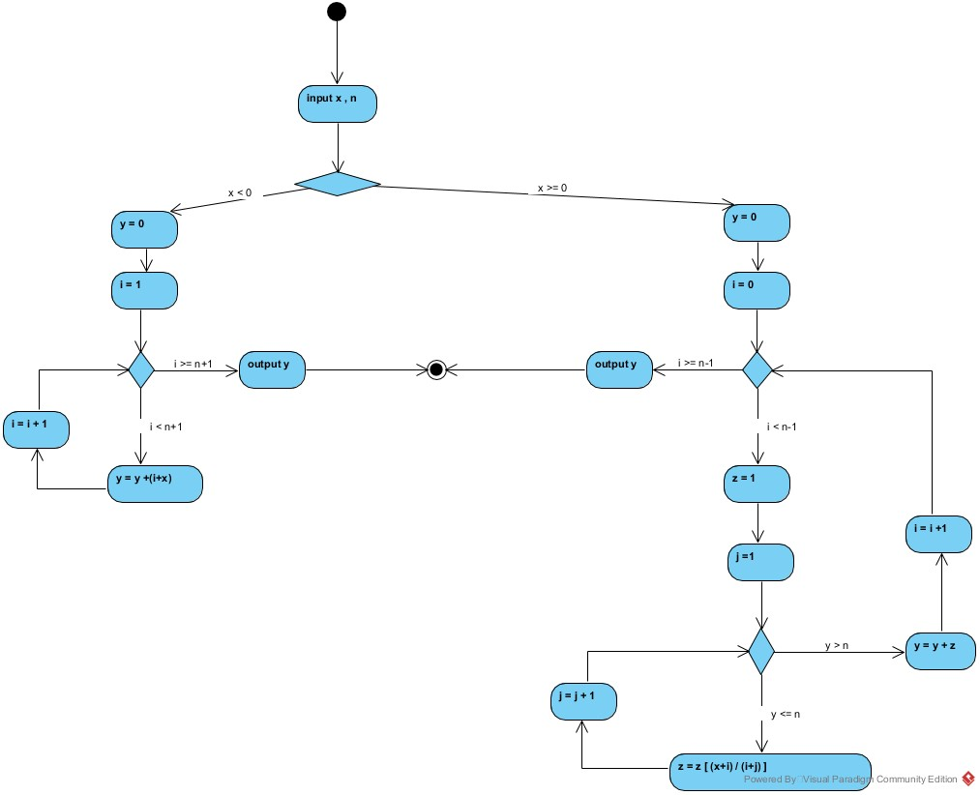

Use – case diagram

